**AUTOMATING TRAFFIC MICROSIMULATION FROM SYNCHRO UTDF TO SUMO**

Xiangyong Luo1, Yiran Zhang2, Guanhao Xu1, Wan Li1, Ross Wang1 and Xuesong Simon Zhou3

1 Buildings & Transportation Science Division, Oak Ridge National Laboratory (ORNL), Oak Ridge, TN

2 The Intelligent Urban Transportation System (iUTS) Lab, Department of Civil and Environmental Engineering, University of Washington, United States

3 School of Sustainable Engineering and the Built Environment, Arizona State University, 660 S. College Avenue, Tempe, AZ 85287-3005, USA

ABSTRACT

Modern transportation research relies on seamlessly integrating traffic signal data with robust network representation and simulation tools. We present utdf2gmns, an open-source Python tool that automates the conversion of Synchro’s UTDF Format, including network representation, signalized intersections, turning volumes into the GMNS Standard. The resulting GMNS-compliant network can be converted for simulation in SUMO. By automatically extracting intersection control parameters and aligning them with GMNS conventions, utdf2gmns minimizes manual preprocessing and reduces data loss. It also integrates with the Sigma-X engine to extract and visualize key traffic control metrics such as phasing diagrams, turning volumes, movement capacities, volume-to-capacity (V/C) ratios, and control delays. This streamlined workflow enables efficient scenario testing, accurate model building, and consistent data management. Validated through case studies, utdf2gmns reliably models complex urban corridors. As a free, open-source solution, it promotes reproducibility and standardization. Documentation is available on [GitHub](https://github.com/xyluo25/utdf2gmns) and [PyPI](https://pypi.org/project/utdf2gmns/), supporting easy integration and community engagement.

# INTRODUCTION

Traffic microsimulation is essential for evaluating and enhancing urban transportation systems, providing insights into traffic flow management, congestion mitigation, and infrastructure improvements. Accurate simulations require precise representation of traffic signals, network geometries, and turning movements. However, conventional approaches to preparing simulation-ready networks, particularly from popular tools such as Synchro, remain largely manual and error-prone. Synchro's Universal Traffic Data Format (UTDF) provides comprehensive intersection data but lacks efficient interoperability with microsimulation software, leading to labor-intensive data preparation, potential inaccuracies, and inconsistencies.

Several critical challenges persist in effectively converting Synchro UTDF data into microsimulation-compatible networks. One primary challenge is signal conversion. Translating intersection control parameters accurately into standardized formats involves detailed extraction, interpretation, and alignment of signal phasing, timing, and coordination data. Inaccuracies in this step can significantly affect the reliability of simulation outputs, underscoring the necessity for precise and automated methods. Another substantial challenge involves network conversion. Synchro typically utilizes relative coordinate systems, which must be converted into real-world geographic coordinates (longitude and latitude) for effective integration with Geographic Information Systems (GIS). This conversion process is often tedious, error-prone, and requires considerable manual effort, complicating large-scale or complex network simulations. Additionally, accurate turning flow conversion is essential for realistic simulation of intersection dynamics. Converting turning movement data, which is crucial for capturing the complexity of urban traffic interactions, frequently involves extensive manual preprocessing. Imprecise conversion in this stage can propagate through simulations, compromising the accuracy and usefulness of the resulting analyses.

Existing research and implementations have not yet provided comprehensive solutions to all the identified challenges simultaneously. Zhang (2024) introduced a method to convert Synchro signal data to a SUMO network; however, this conversion requires preliminary preparation of both the Synchro UTDF file and the SUMO network separately. Ban (2022) converted Synchro signal data into SUMO to facilitate calibration within a vehicle-traffic-demand (VTD) simulation platform; however, the networks used in Synchro and SUMO were prepared independently and differently. Coogan (2021) conducted an early effort to convert Synchro's geometric and phasing data into SUMO, primarily emphasizing geometry conversion. Nevertheless, their network conversion employed relative coordinates and was limited to selected intersections, lacking automation and scalability for broader application. Udomsilp (2017) leveraged Synchro for optimizing network signal timings, specifically cycle lengths, and subsequently employed these optimal cycle lengths as inputs into SUMO simulations to evaluate travel-time improvements. Similarly, Singh (2017) utilized Synchro for traffic signal optimization, incorporating optimal green times into SUMO simulations to assess start-up lost times. Despite these contributions, a fully integrated and automated solution remains lacking in current literature.

To address these gaps, we introduce utdf2gmns (Luo and Zhou 2022), an open-source Python tool designed to automate the conversion of Synchro UTDF files into GMNS-compliant ([General Modeling Network Specification](https://zephyr-data-specs.github.io/GMNS/)) networks suitable for simulation in the widely used SUMO platform (Figure 1). By combining the advantages of the GMNS, a robust framework that standardizes network representation (Berg and Zhou 2022; Lu and Zhou 2023; Luo et al. 2024; Luo 2024), enhances data consistency, reproducibility, and collaboration, utdf2gmns specifically contributes through the following functionalities: (1) Automatic geocoding of Synchro networks, automates the transformation of relative coordinates into precise longitude and latitude, significantly reducing manual effort and ensuring accurate spatial representation. (2) Enhanced [Sigma-X](https://www.youtube.com/watch?v=Q1CxQFM9D5U) (SIGnal Modeling Application for eXcel) engine integration, leverage the Sigma-X engine to automatically extract, calculate, visualize, optimize essential signalized intersection metrics. This includes detailed phasing diagrams, turning volume statistics, movement capacities, volume-to-capacity (V/C) ratios, and intersection control delays, providing comprehensive analysis and facilitating informed decision-making. (3) Robust SUMO network generation, utdf2gmns carefully generates GMNS-compliant SUMO simulation networks by fully considering critical parameters such as signal coordination, traffic flows, and turning movements, thus accurately reflecting real-world operational scenarios. (4) Extendibility to other microsimulation platforms, built as an open-source modular tool, utdf2gmns enables easy adaptation and extension to additional simulation software platforms beyond SUMO. This promotes broader standardization, reproducibility, and community-driven enhancement in traffic simulation research.



Figure 1: Design Framework of utdf2gmns

# METHODOLOGY

To accurately and automatically convert Synchro networks (in UTDF format) into SUMO for extended microsimulation, several critical aspects must be addressed. These include converting the original network coordinates from relative to real-world geographical coordinates (longitude and latitude), extracting and translating signal information from the original files into SUMO-compatible formats, converting turning flow data, and calculating essential performance metrics. The methods presented in this chapter aim to systematically resolve these issues.

## 2.1 Network Coordinating

The first and most critical step in the automation process is converting the Synchro network into a real-world network that can be accessed using GIS and other simulation software. In this section, we introduce two methods to transform the original network into a universally readable format (GMNS). The first method automatically geocodes intersections, while the second method requires manually inputting the coordinate of one intersection.

### 2.1.1 Automatic Geocoding

The UTDF file provides link names in the network. The logic for coordinate validation (Figure 2) involves iterating through each intersection and extracting directional link names, then applying a double-confirmation approach to validate the intersection's coordinates. If one valid coordinate for an intersection is confirmed, the iteration stops; otherwise, the process continues to the next intersection. In the worst scenario, where no coordinates are identified, the program will prompt the user to confirm the network’s location or switch to the manual geocoding method. After successfully validating coordinates for one intersection, all remaining intersections are mapped by converting their relative coordinates into real-world positions based on the validated reference point.



Figure 2: Two methods of coordinating intersections

### 2.1.2 Manual Geocoding with One Given Coordinate

Manual geocoding requires minimal effort, as only one coordinate is necessary. In this step, users need to provide a single intersection ID paired with its coordinates ("INTID": intersection ID, "coord_x": longitude, "coord_y": latitude). As illustrated in Figure 2, once the coordinate of one intersection is confirmed, the program uses this reference point to geocode all other intersections accordingly.

## 2.2 Signal Conversion

Signal information is essential for microsimulation, and accurately converting signal data from Synchro to SUMO plays a critical role in the automation process. Properly converted signals enable SUMO to utilize its extensive functionalities for traffic control and optimization. This paper extracts detailed signal information, including Phases, Timeplans, and Lanes from the UTDF file. Two key concepts guide the signal conversion: network direction mapping and phase mapping. For direction mapping, Synchro uses predefined movement directions (Figure 3), whereas SUMO represents traffic signals as state-based strings, with each character indicating specific lane-to-lane movements. Regarding phase mapping, Synchro employs a [Ring-and-Barrier Designer](https://ops.fhwa.dot.gov/publications/fhwahop08024/chapter4.htm), automatically managing signal transitions based on Barrier, Ring, and Position (BRP) assignments. In contrast, SUMO encodes signal states as strings indicating signal colors—Green (G/g), Yellow (y), and Red (r)—with uppercase denoting protected and lowercase indicating permitted movements. SUMO supports various signal controllers, including pre-timed, actuated, and [NEMA](https://www.webpages.uidaho.edu/TrafficSignalSystems/traffic/instructor/ch3a.pdf)-type Dual-Ring-Barrier controllers (Schrader et al., 2022; Halbach and Erdmann, 2022).

Direction mapping approach converts edge slopes into directions compatible with Synchro and associates this information with SUMO. The vehicular movement directions in SUMO are then determined by combining turning directions from connection data with previously assigned directional information, prioritized in the order of right turn (R), through (T), and left turn (L). Unlike vehicular movements, pedestrian crossings do not have unique directional bounds, as pedestrians can cross intersections bidirectionally (e.g., Eastbound to Westbound and vice versa). Thus, pedestrian crossing directions in SUMO are identified starting from crossing edges corresponding to the initial vehicular direction. Consequently, accurately defining pedestrian crossings requires identifying their corresponding vehicular crossing edges. Phase mapping methodology is demonstrated using a Ring-Barrier-Controlled signal. The process begins by extracting all valid phases from Synchro. A Breadth-First Search algorithm is then applied to identify feasible combinations of green phases. Synchro phase numbers are translated into SUMO lane-based signal states using Connection-to-Direction mapping, which aligns SUMO’s link indices with the corresponding Synchro Lane groups. Finally, bitwise comparisons between adjacent green phases are conducted, with yellow and all-red phases interpolated to ensure smooth phase transitions and accurate signal timing.

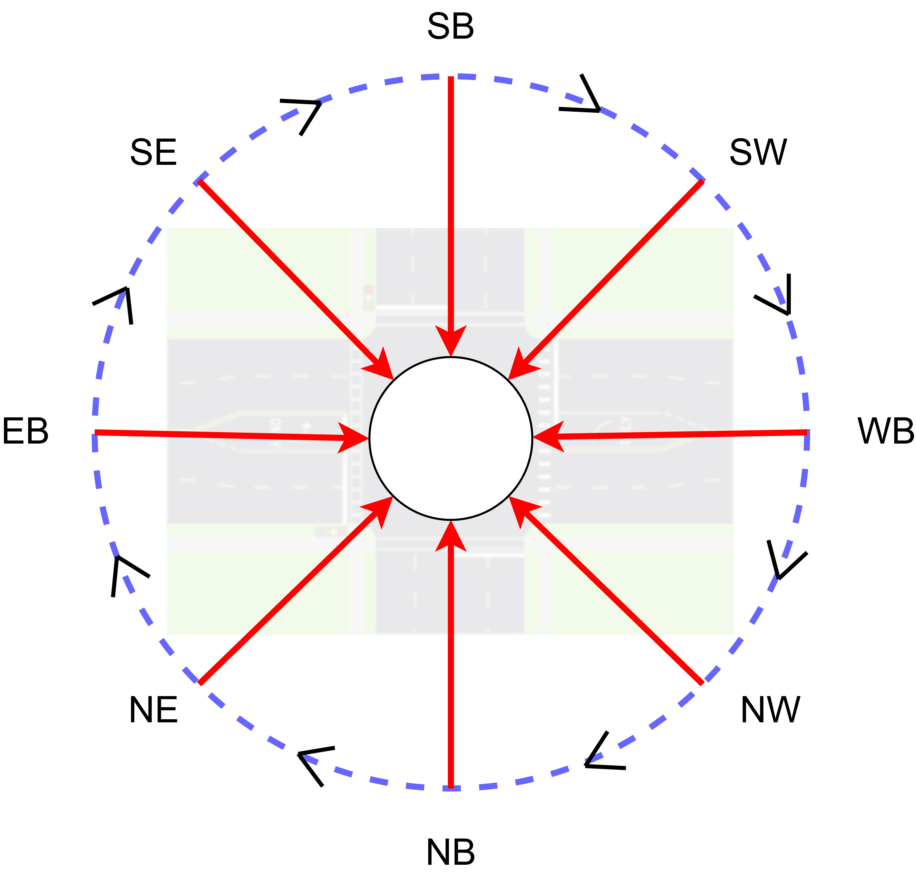

Figure 3: Direction order in Synchro

## 2.3 Traffic Flow Conversion

Turning volumes from the UTDF file are indicated in vehicles per hour. In Synchro, turning volumes are specified individually for each direction (Left, Through, Right, and U-Turn). However, SUMO automatically generates U-turn volumes for all possible connections, which could negatively affect the accuracy of the network conversion. To address this, we allow U-turns in the converted SUMO network only if they are explicitly specified in the UTDF file. In this section, we extract left, through, and right turning volumes from the UTDF file and generate the corresponding flow files for SUMO.

## 2.4 Sigma-X Powered Performance Calculation

Sigma-X is a powerful engine developed in VBA by Prof. Milan at the University of Wyoming, originally created between 2012 and 2022 under a GNU License. Development resumed in 2025 from us to address challenges in handling large and complex networks and to improve result generation and management. The tool extracts key data such as intersection volumes, signal timings, inbound and outbound flows, link structures, and lane configurations. It calculates and visualizes critical performance metrics for signalized intersections, including volume-to-capacity (V/C) ratios, Level of Service (LOS), turning volumes, signal phasing, control delays (in seconds), split durations, movement capacities (vehicles per hour), and more. Additionally, Sigma-X can optimize existing signal timings and updating the corresponding performance metrics in real time.

### 2.4.1 Overview of Signalized Intersection

The overview of the signalized intersection will combine extracted and calculated parameters into one figure with centralized with the intersection name. Figure 4 shows the sample overview features. As shown in the figure, the center is the intersection, then from center extended with movement directions for each direction. There are number of lanes and volumes are corresponding to each movement and will be updated from UTDF data. The right turn on read (RTOR) specified for each right turn lane as well. Then speed will be updated as well, such EB Speed, WB Speed, NB Speed and SB Speed. For each direction, the street name will also be updated.

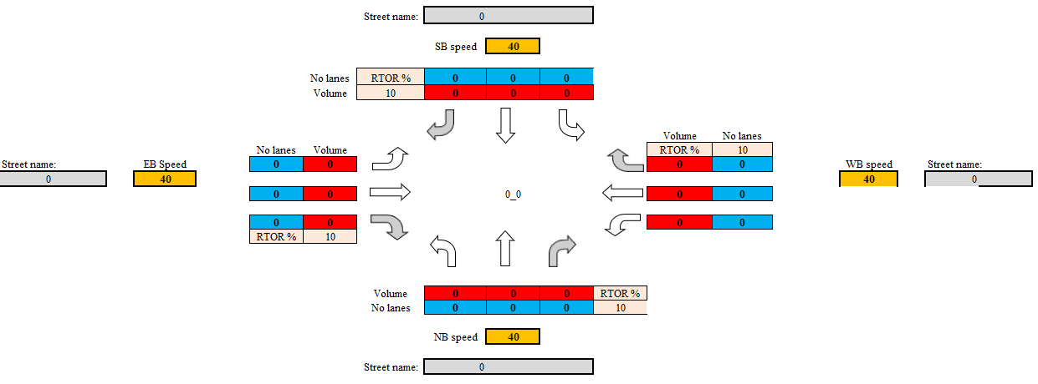

Figure 4: Overview of the signalized intersection

### 2.4.2 Signal Phasing

Phasing information is extracted and processed from UTDF file, which provides detailed signal timing parameters such as cycle lengths, phase splits, offsets, and protected/permissive movements. These raw data are parsed to reconstruct the operational logic of traffic signals at each intersection, offering insights into how signal phases are coordinated across the network. Once extracted, the processed signal phasing data are used to generate visual representations in the form of phase timing charts. These charts illustrate the sequence and duration of each phase within a signal cycle, highlighting overlaps and coordination opportunities between adjacent intersections. This visualization not only facilitates verification of signal timing consistency but also supports further analysis, including delay estimation, progression assessment, and scenario-based simulation under varying traffic conditions.

### 2.4.3 Turning Volume and Number Lanes

Turning volume data offers essential insights into intersection-level traffic dynamics by capturing the directional flow of vehicles at each approach. To aid interpretation, the extracted turning volumes are visualized using movement-specific charts that illustrate traffic flow intensity by direction. These visualizations help identify imbalances in movement demand, potential bottlenecks, and critical turning movements that may warrant signal timing adjustments or geometric modifications. By presenting the data in a clear and intuitive format, the analysis supports more informed decision-making in traffic signal optimization and intersection design.

### 2.4.4 V/C Ratio and Movement Capacity

The Volume-to-Capacity (V/C) ratio is calculated using data extracted from UTDF file, the ratio quantifies the degree of saturation at an intersection, with higher values indicating potential congestion. Visual charts generated from the V/C data highlight critical movements where demand approaches or exceeds capacity, serving as an essential diagnostic tool for identifying intersections that may require signal optimization or capacity enhancements. In addition to the V/C ratio, movement capacity is assessed to gain deeper insight into the operational limits of each intersection movement. Movement capacity represents the maximum number of vehicles that can be processed by a specific approach under prevailing signal timing and geometric conditions. To enhance interpretability, the computed V/C ratios are presented through visual charts that illustrate the performance of each intersection. These charts highlight critical movements with high V/C ratios, indicating potential delays or capacity shortfalls. Such visualization supports quick identification of problem areas within the network and serves as a basis for prioritizing signal optimization, capacity enhancements, or geometric redesigns.

### 2.4.5 Level of Service and Control Delay

Level of Service (LOS) is a standardized metric used to evaluate the performance of signalized intersections, representing the quality of traffic flow experienced by drivers. It is categorized from A to F, with LOS A indicating minimal delays and optimal efficiency, and LOS F reflecting severe delays and breakdown conditions. In this study, LOS is determined following the methodologies outlined in the [Highway Capacity Manual (HCM 6th Edition)](https://www.trb.org/Main/Blurbs/175169.aspx), which defines LOS based on control delay per vehicle measured in seconds, the additional time a vehicle spends at an intersection compared to uninterrupted flow. Using data including approach volumes, lane configurations, and signal timing, control delays are computed, and LOS values are assigned to each approach and intersection accordingly. The results are visualized through clear, data-driven charts that highlight operational efficiency across the network. These visualizations not only convey overall intersection performance but also pinpoint specific areas where high control delays (e.g., LOS E or F) occur. This enables traffic engineers to identify critical problem areas and implement targeted interventions such as signal retiming, lane reconfigurations, or capacity enhancements to improve overall network performance.

### 2.4.6 Split Durations (Seconds)

Split duration refers to the allocation of green time among various signal phases within a cycle at a signalized intersection, serving as a key parameter in signal timing that directly affects intersection performance, vehicle delay, and traffic progression. In this study, split durations are extracted, calculated and then used to generate visual charts that depict how green time is distributed across different movements within each cycle. These visualizations help evaluate the alignment between signal timing and traffic demand, identifying potential inefficiencies such as over- or under-allocated phases. By supporting data-driven adjustments to signal timing plans, this analysis promotes more effective use of intersection capacity and contributes to smoother and more balanced traffic flow.

## 2.5 SUMO Generation

The generation of a SUMO network from a Synchro-based model involves a multi-step automated process utilizing SUMO's [netconvert](https://sumo.dlr.de/docs/netconvert.html) and [jtrrouter](https://sumo.dlr.de/docs/jtrrouter.html) tools. The workflow begins with the geocoding of intersections, which provides the foundation for deriving the geometry and structure of links and lanes. Using the geocoded intersection data, the corresponding link and lane files are generated to define the physical and directional attributes of the network. Once these spatial components are created, they are integrated using the [netconvert](https://sumo.dlr.de/docs/netconvert.html) tool to produce a base network file (net.xml) in SUMO format. Following network construction, the next critical step is the integration of traffic signal information. This involves mapping detailed signal phasing and timing data (previously extracted from Synchro UTDF files) into SUMO-compatible formats, ensuring accurate representation of signalized intersections. Subsequently, turning movement data is processed and converted into vehicle flow definitions, enabling the simulation of realistic traffic patterns. These flows are configured to match the geometric and signal characteristics of the network. Finally, a comprehensive SUMO configuration file (.sumocfg) is generated to coordinate all components of the simulation, including network files, route files, and signal definitions. This structured pipeline enables a seamless transformation from planning-level Synchro models to microsimulation-ready SUMO environments.

### 2.5.1 Network Conversion

To convert the GMNS-based network into a SUMO-compatible format, we begin by transforming real-world intersection coordinates into UTM format, as required by SUMO, which uses meters (m) and meters per second (m/s) for distance and speed units. Using these converted coordinates and associated speed data, we generate the nod.xml file representing node (intersection) information. Lane and Link data, including turning movements, are then processed to create edg.xml, with each lane indexed per SUMO's convention, starting from the rightmost lane as index 0. Lanes are grouped to form links, and directional flow is preserved during this process. The con.xml file is then created to define connections between edges and lanes, including turning relationships, which are critical for modeling intersection behavior.

Once the base files (nod.xml, edg.xml, con.xml, and add.xml) are automatically generated, we integrate loop detector information from the original lane data, particularly important for signalized intersections, to enhance traffic simulation accuracy. These files are then passed to the SUMO [netconvert](https://sumo.dlr.de/docs/netconvert.html) tool, which compiles them into a unified net.xml file representing the complete traffic network. This structured approach enables automated, scalable, and accurate network conversion from GMNS/UTDF data into SUMO format.

### 2.5.2 Signal Integration

At this stage, the generated net.xml file does not yet contain signal control information for signalized intersections. Signal integration is carried out by incorporating the extracted and converted signal data into the existing network structure. This process updates the net.xml file to include detailed signal configurations based on the previously processed timing and phasing data. As illustrated in Figure 5, signal control logic is successfully embedded into the appropriate intersections, enabling accurate representation of real-world traffic signals within the SUMO network.

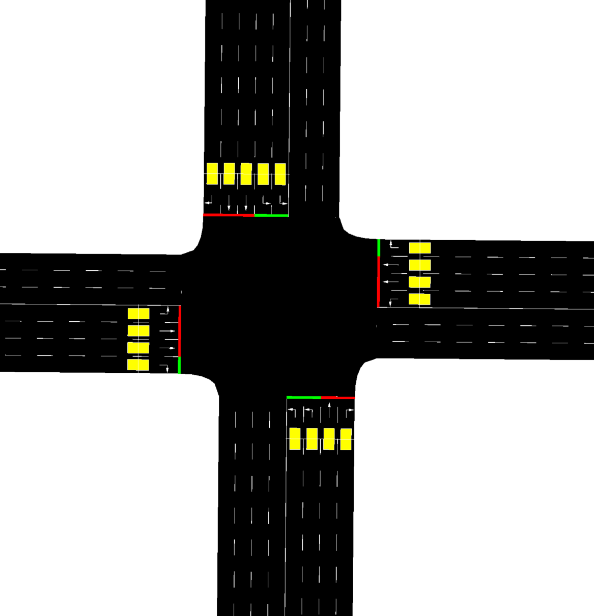

Figure 5: Signalized Intersection

### 2.5.3 Turning Configuration

Turning configuration is a critical step in ensuring accurate vehicle movement patterns within the SUMO simulation. Using the extracted link and lane data, turning volumes for each movement are identified at the edge and lane levels. This information is used to generate the flow.xml file, which defines the volume and direction of traffic flows across the network. The flow.xml, together with the previously generated net.xml, is then used as input for SUMO’s [jtrrouter](https://sumo.dlr.de/docs/jtrrouter.html) tool to create the rou.xml file. The rou.xml file contains route definitions that translate turning movements into simulated vehicle paths across the network. To ensure that the turning flows from Synchro are correctly represented in SUMO, several constraints are applied during route generation. One important constraint is the prohibition of loop routes, which can otherwise result in vehicles exiting and re-entering the network through dead-end paths. Additionally, U-turns are invalidated unless explicitly defined in the original Synchro data, as SUMO may otherwise automatically generate U-turn connections that distort turning volume accuracy. These adjustments help maintain consistency between Synchro’s planned traffic flows and SUMO’s simulation behavior, enabling reliable and realistic traffic modeling.

### 2.5.4 SUMO Configuration

Once the SUMO network file (net.xml) is generated, simulation parameters such as start time and duration are extracted from the UTDF file to create the SUMO configuration file (.sumocfg). This file plays a central role in defining how the microsimulation will be executed. It specifies essential simulation inputs, including the network, route, and signal files, as well as simulation time settings. Additionally, the .sumocfg file allows users to configure various output options for detailed analysis, such as vehicle emissions, floating car data, loop detector readings, lane-changing behavior, and car-following dynamics. These outputs provide valuable insights into network performance and traffic behavior under different conditions. The configuration file thus serves as the control hub for simulation execution, ensuring all components are correctly integrated and tailored to meet specific analysis goals.

# CASE STUDY

## 3.1 Study Area

This study selects downtown Tempe as the study area, as depicted in Figure 1,

There are 755 intersections in the network with 227 signalized intersections.

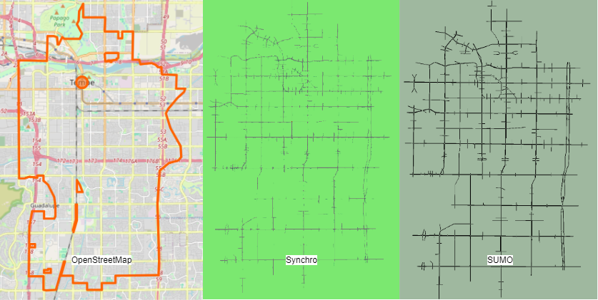

Figure 1: City of Tempe showing in OpenStreetMap, Synchro network and SUMO network (order from left to right)

illustrates the complexity of intersections within a large-scale network, highlighting the challenges associated with integrating Synchro and SUMO. The network features a range of intersection types, extending beyond the conventional four-way to include three-way and even five-way and six-way intersections. Additionally, the presence of signal protection at these intersections varies greatly, encompassing factors such as pedestrian phases, protected left or right turns, and different signal timing plans ranging from fixed to adaptive and actuated timing. This diversity significantly complicates the process of implementing integration between Synchro and SUMO, as each intersection type and signalization approach demands careful consideration and unique handling within the simulation models.

## 3.2 Automation in Intersection Key Features Visualization

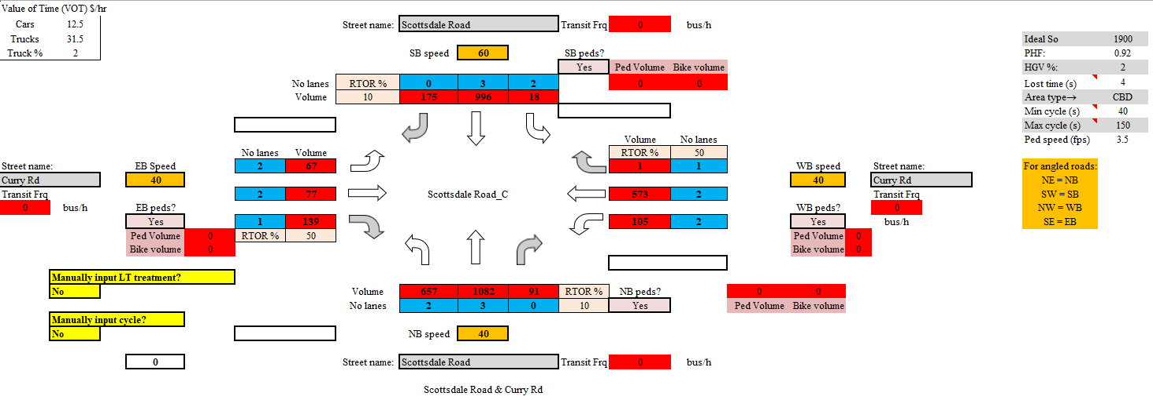

Overview of signalized intersection

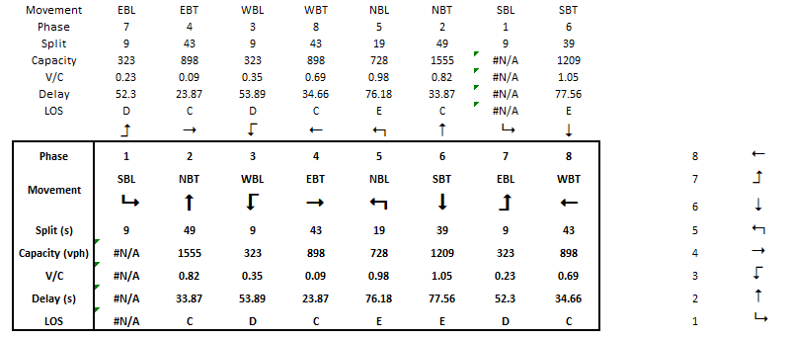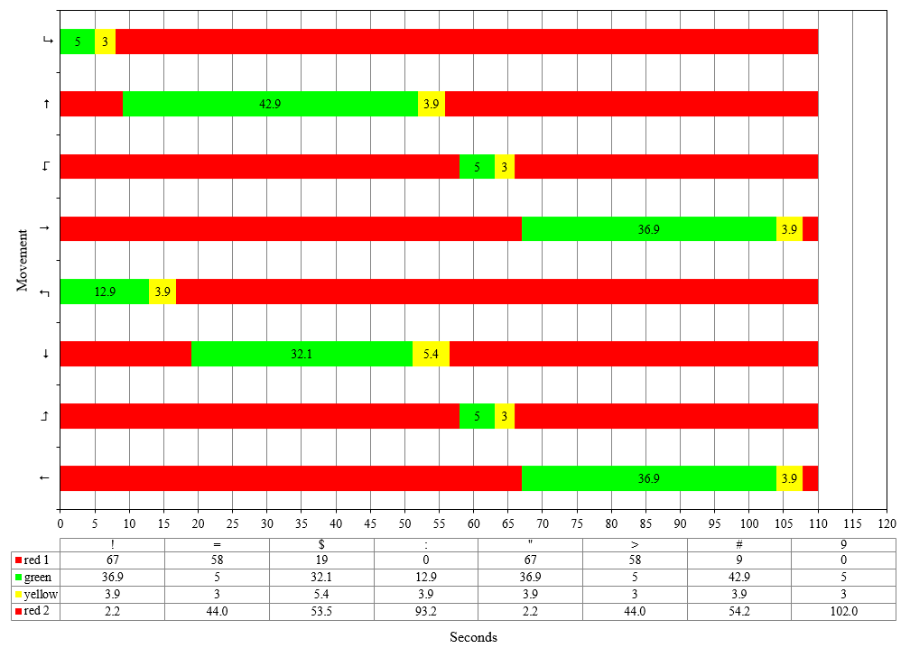

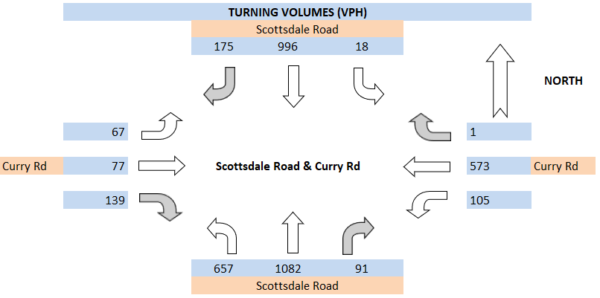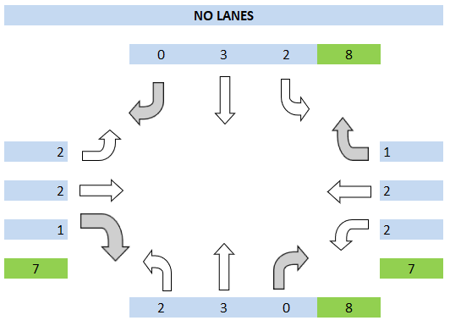

v/c ratio

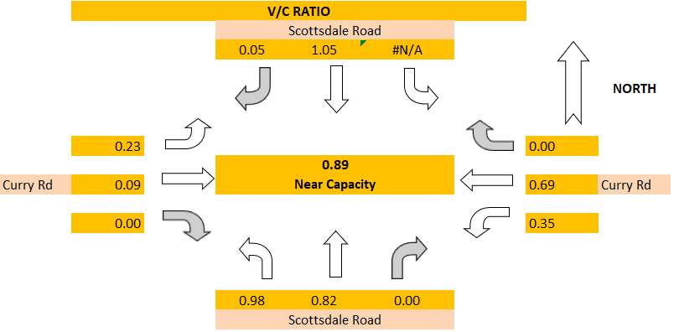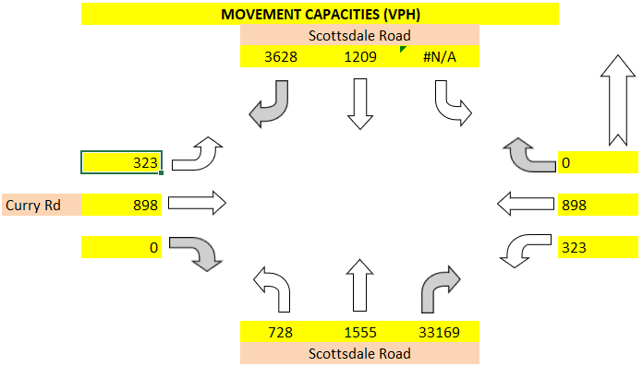

Los control delay

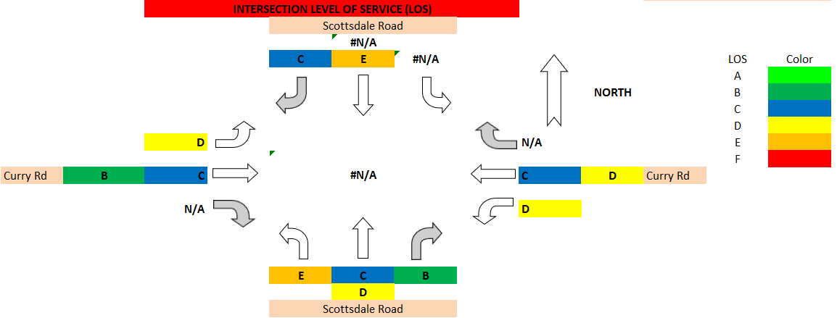

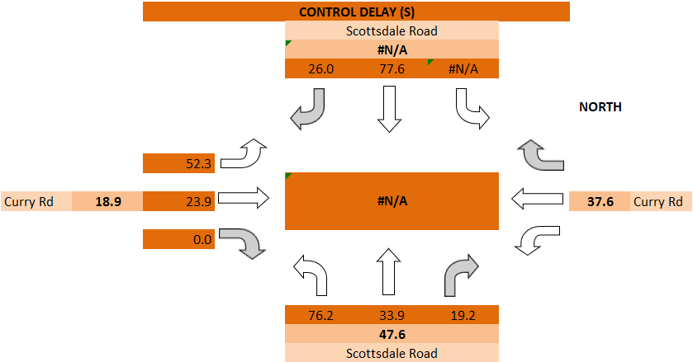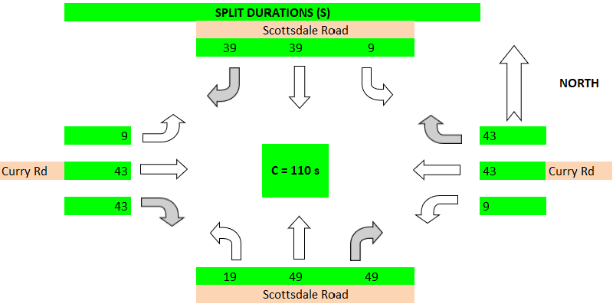

Split durations

## 3.3 Automation in SUMO Microsimulation

### 3.3.1 Network

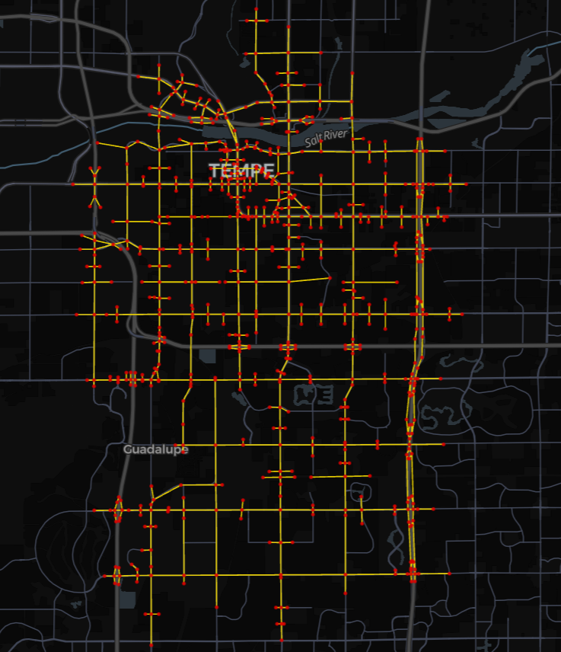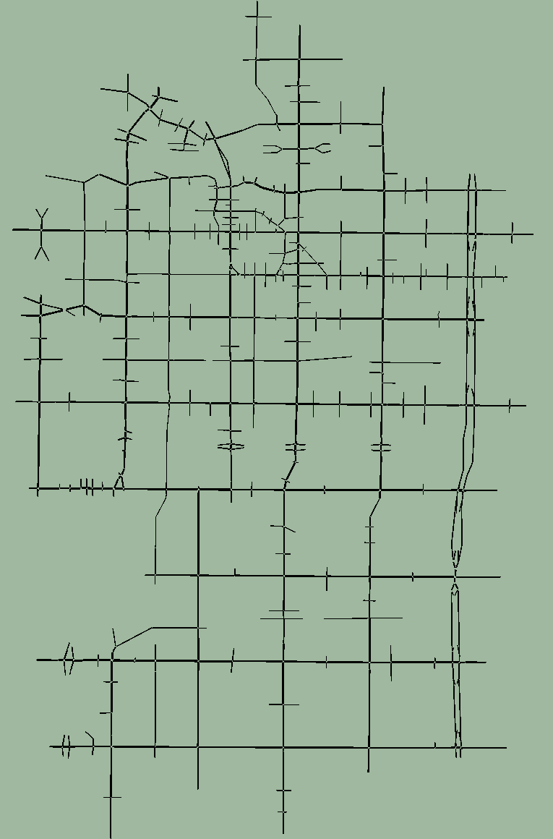

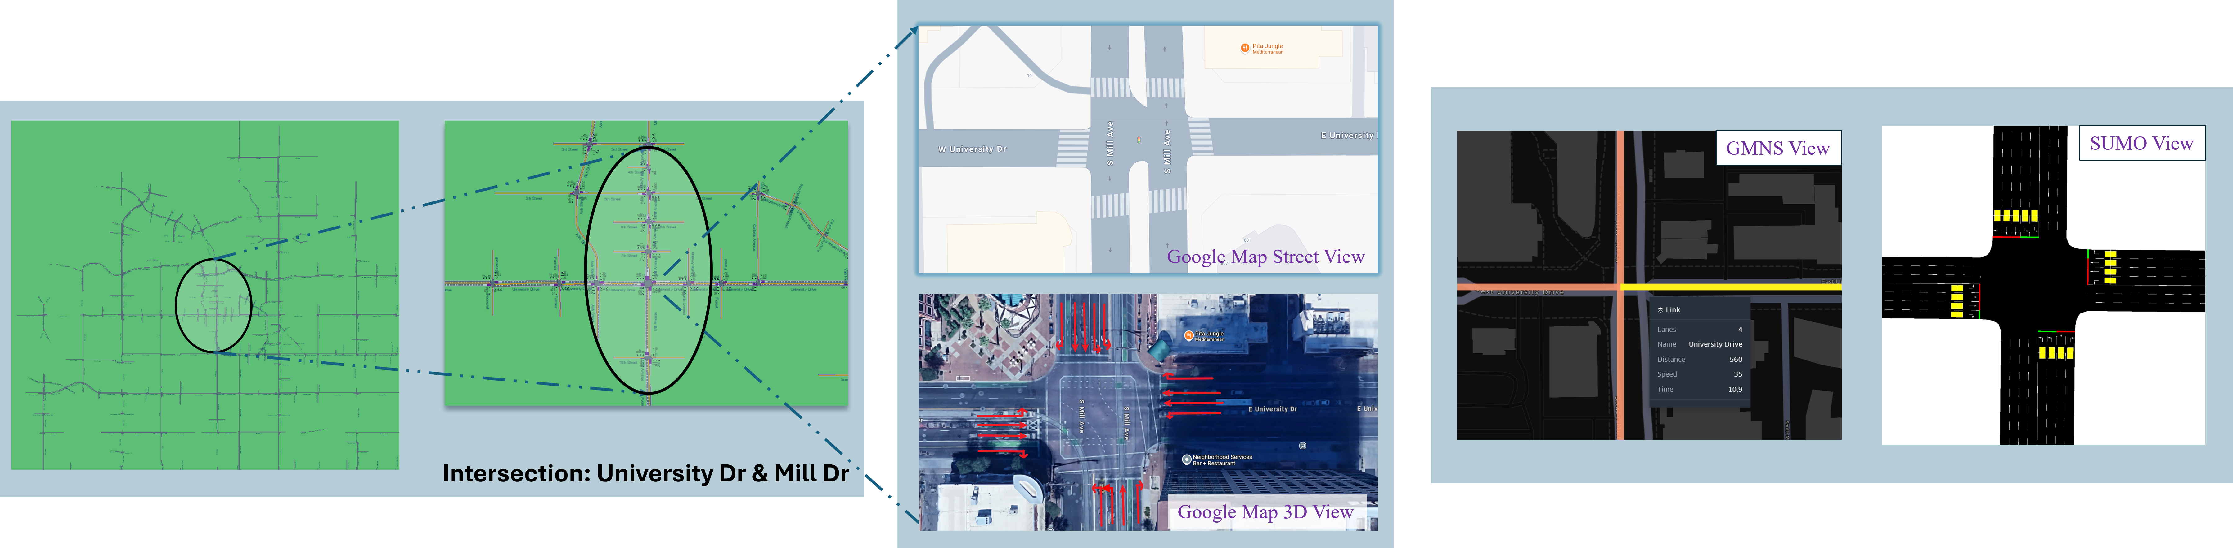

### 3.3.2 Intersection Features

### 3.3.3 Signal and Turning Flow

# CONCLUSION AND FUTURE WORK

In this paper, we explored the process of integrating traffic signal data from Synchro to SUMO, identifying both the feasibility and challenges involved. Our approach began with a comparative analysis of traffic network features, data formats, and signal timing schemas between the two platforms. Despite similarities in road network features, significant differences in traffic signal timing plan encodings presented obstacles, especially in large-scale networks.

To overcome these challenges, we introduced a four-stage approach encompassing Data Preparation, Connection-to-Direction Mapping, Signal Phase Mapping, and Data Revision and Output. This methodology focused on extracting relevant signal timing and road features, aligning inbound directions, and generating lane-specific signal states for each timing phase. We then converted this data into SUMO's XML format. Our semi-automated pipeline, developed in Python, was tested on two Synchro models in downtown Seattle. The success rate exceeded 85%, demonstrating the pipeline's ability to handle various intersection layouts and signal controller types. However, the integration is not flawless in large-scale networks, necessitating manual checks for complex intersections.

The proposed four-stage approach can help researchers and modelers integrate the signal timing data from Synchro to SUMO more efficiently. This study delved into the intricacies of signal control mechanisms within both platforms. For future work, this framework could be foundational for extending traffic signal integration from Synchro/SUMO to other platforms. While the results in large-scale networks are promising, they still require manual validations and revisions in complex scenarios, such as the mismatching geometry coding between Synchro and SUMO and intersections with an exclusive pedestrian phase. Further refinement through specific algorithms is needed to enhance signal integration accuracy. Additionally, we envision supporting the integration of advanced signal control features, such as coordinated signal control, to elevate the quality of simulation. Beyond traffic signal control integration, this four-stage approach may hold the potential for integrating a wider range of Synchro features into SUMO, including links, routes, and detectors.

ACKNOWLEDGMENTS

Place the acknowledgments section, if needed, after the main text but before any appendices and references. The section heading is not numbered. These instructions are adapted from instructions that have been iteratively updated and improved by proceedings editors and several other individuals, who are too numerous to name separately, since the first set of instructions was written by Barry Nelson for the 1991 WSC.

REFERENCES

Ban, J., Angah, O., Zhang, Y. and Guo, Q., 2022. A multiscale simulation platform for connected and automated transportation systems.

Berg, I., Smith, S. and Zhou, X.S., 2022. GMNS: A Specification for Sharing Routable Road Networks (No. TRBAM-22-02127).

Coogan, S. and Thitsa, M., 2021. Coordinated Anti-Congestion Control Algorithms for Diverging Diamond Interchanges (No. FHWA-GA-21-1913). Georgia. Department of Transportation. Office of Performance-Based Management & Research.

Halbach, M. and Erdmann, J., 2022, September. High fidelity modelling of traffic light control with XML logic representation. In SUMO Conference Proceedings (Vol. 3, pp. 45-68).

Lu, J. and Zhou, X.S., 2023. Virtual track networks: A hierarchical modeling framework and open-source tools for simplified and efficient connected and automated mobility (CAM) system design based on general modeling network specification (GMNS). Transportation Research Part C: Emerging Technologies, 153, p.104223.

Luo, X., 2024. Strategic Planning for Scalable Electric Vehicle Charging Networks: Integrating Operational Dynamics and Spatial-Temporal Analysis (Doctoral dissertation, Arizona State University).

Luo, X., and Zhou, X.S., 2022. “Xyluo25/utdf2gmns: V1.0.0”. Zenodo, December 17, 2022. https://doi.org/10.5281/zenodo.14825686.

Luo, X., Kuby, M.J., Honma, Y., Kchaou-Boujelben, M. and Zhou, X.S., 2024. Innovation diffusion in EV charging location decisions: Integrating demand & supply through market dynamics. Transportation Research Part C: Emerging Technologies, 165, p.104733.

Schrader, M., Wang, Q. and Bittle, J., 2022, September. Extension and validation of nema-style dual-ring controller in sumo. In SUMO Conference Proceedings (Vol. 3, pp. 1-13).

Singh, S.K., Komolkiti, P. and Aswakul, C., 2017. Impact analysis of start-up lost time at major intersections on sathorn road using a synchro optimization and a microscopic SUMO traffic simulation. IEEE Access, 6, pp.6327-6340.

Udomsilp, K., Arayakarnkul, T., Watarakitpaisarn, S., Komolkiti, P., Rudjanakanoknad, J. and Aswakul, C., 2017. Traffic data analysis on sathorn road with synchro optimization and traffic simulation. Engineering Journal, 21(6), pp.57-67.

Zhang, Y., Fu, M. and Ban, X., 2024, July. Integration Traffic Signal Control From Synchro to SUMO. In SUMO Conference Proceedings (Vol. 5, pp. 147-162).

AUTHOR BIOGRAPHIES

**Xiangyong Luo** is a Postdoctoral Researcher at Oak Ridge National Laboratory (ORNL). His research interests include transportation network optimization, simulation, control, facility location problems and local statical modeling. His email address is [luox1@ornl.gov](mailto:luox1@ornl.gov) and his website is <https://github.com/xyluo25>.

**Yiran Zhang** is ~~an Associate Professor for Computer Science at the University of Applied Sciences Ingolstadt. He received his Ph.D. degree (Dr.-Ing.) and his M.Sc. in computer science (Dipl.-Inf. Univ.) from the engineering faculty of the University of Erlangen-Nuremberg in 2015 and 2008, respectively. Until 2010, he worked as a software engineer within the area of model-based testing and automated test case generation. Thereafter, he was leading a research grop for Connected Mobility at the University of Erlangen-Nuremberg. His previous research focus was related to prospective assessments of health technologies, and healthcare decision-support. His current research interests include various topics on simulation and modeling using agent-based simulation, and hybrid simulation. Major application areas are simulation of healthcare systems, vehicular networks, innovative aspects of connected mobility, and future mobility services. His email address is~~ [~~anatoli.djanatliev@thi.de~~](mailto:anatoli.djanatliev@thi.de) ~~and his website is~~ [~~https://www.thi.de/en/computer-science/people-i/prof-dr-anatoli-djanatliev~~](https://www.thi.de/en/computer-science/people-i/prof-dr-anatoli-djanatliev)~~.~~